Direct Payments Q&A
December 2020
Introduction
On the 3rd December 2020, in partnership with the Department of Health and Social Care (DHSC) NHS England & Improvement (NHSE&I) and Community Health Partnerships (CHP), we ran a customer webinar to outline how Direct Payments for reimbursable costs works, and some of the benefits it can offer.

We were delighted to welcome so many customers, partners and colleagues to the session, and due to the level of engagement were unable to answer all the questions asked in our Q&A. We want to equip our customers with as much information as possible as we move into this next phase of Direct Payments, and so have prepared responses to all questions asked throughout the session.

Resources
You can also watch a recording of the webinar, view the slides used, and access other supporting materials such as our main FAQs and the Section 52 letter. This can all be found on our webinar summary page here.

For any outstanding queries or concerns, or if you would like to discuss how to set up Direct Payments, please contact Harj Brar at NHS Property Services (harj.brar@property.nhs.uk) or Kevin Breen at Community Heath Partnerships (CHP) (k.breen@communityhealthpartnerships.co.uk).

Q&A
- Does the process of Direct Payments under S52 of the Premises Cost Directions 2013 (Current PCDs) create an implied lease between the CCG and the property companies?
No this is not the case. The liability does not fall on the CCG (nor does it impact on the CCG’s Agreement of Balances etc) as the invoice is raised against the GP’s accounts in line with the Premises Cost Directions’ guidance.

- Will the changes to the new PCDs impact on the process?
We have been advised that the anticipated changes to the PCDs will not impact on the process.

- Does a CCG need to send out the S52 letter every year?
No, we would expect this to be sent out once at the start of the process, however should the lead partner resign, a new letter should be sent out and signed to ensure the practice’s records are up to date. For subsequent financial years, the property companies would send a statement to the practice and the CCG setting out the costs for that year, and this would provide the GP and the CCG with the opportunity to engage and review the new financial years’ charges for example flagging any prospective changes of which they may be they may be aware.

- Is the payment process going to be automated?
NHSE&I has developed a new GP payments and pension system which includes a model that will automate the direct payments process for reimbursables and prevent the need for manual payment requisitions. This is expected to go live in 2021.

- Does Direct Payments have any VAT implications?
No. All VAT arrangements remain the same, the liability remains with the GP.

- What is the lead time?
This is dependent on a number of factors, but generally it requires a couple of months lead in, to get the S52 letters signed etc, engage with local LMCs and GPs.

- Is there an impact on SFIs?
These are specific arrangements for each CCG, but agreements can be made with the DoF. The payments are set up on an annual basis with known amounts, this is not a short cut to avoid setting a supplier up or to avoid raising a PO. This is simply an arrangement to pay on behalf of the GP claim.

- Will the GP still receive an invoice and a schedule of the costs?
Yes, the GP still receives the Annual Charging Schedules and invoices to enable them to properly account for the transaction in the GP’s accounts. The invoices confirm that the rent, rates, water and clinical waste are paid directly by the CCG to NHSPS. This is followed up with a statement confirming the reimbursable charges have been paid by the CCG and are no longer outstanding.

- Should the management fee be included as a reimbursable cost?
Yes, NHSE&I has agreed that the management fee for reimbursable costs is also reimbursable.

- Is the CCG liable for aged reimbursable debt?
No, but property companies would work with commissioners to ensure any funds passed were known and collectively chased. This is where Direct Payments can help to prevent situations where reimbursable funds are not being used for the intended purpose and creating a potential issue for GPs. We are working with CCGs to help resolve the historic reimbursables issues where GPs have not been paying reimbursable costs.

- What about non-reimbursable debt?
Normal arrangements would apply and the property companies would chase these as part of BAU.

- Do all GPs need to sign up to the scheme for it to go ahead?
No, although this may be preferable to CCGs.

- Can a GP sign up for Direct Payments even if they don’t have a lease in place?
Yes, although clearly we would prefer the GP to have a lease in place to set out the full occupancy position.

- Who initiates this process – CCGs or practices?
This is usually driven by the CCG and the property companies. However, there are instances where GPs have approached the property companies directly to say they would like to do this. In those circumstances, the property company would then engage with the CCG to let them know they have interest from one of their GP practices. The CCGs agreement is required before Direct Payments can go ahead.

- We have a situation where a practice has not claimed their reimbursables and have since lost the contract. We therefore don’t want to pay this to the practice but we are not clear if we have a right to make a direct payment without their authority. Is there a process for doing this?
GPs must sign a Section 52 letter to agree to sign up to Direct Payments and enable CCGs to make payments to the property companies on their behalf. If a GP does not make payments to the property company for its reimbursable costs, then this would result in the appropriate legal action being taken by the property companies. A CCG could make Direct Payments (and acceptance of this by a GP) a condition of the payment of reimbursable funds.

- Primary Care have lots of difficulty with PCSE (Capita) payment processes currently, with working time for feedback and resolution 60 days upwards. In addition, there is a process for them to be making CQRS local payments – do they have enough functional capacity to manage this given their current pressures?
Thank you for the feedback. One of the reasons that NHSE&I have not asked Capita to implement an automated direct payments module in parallel with the ‘go live’ of the new system is to ensure we are all confident of its functionality to deliver the intended outputs.

- One of my CCGs has stated that they refuse to be involved with Direct Payments. Will they become mandatory?
At the moment, Direct Payments will only be mandated for new occupancies or new contractors in NHSPS and CHP properties, however, should there be a debt issue with reimbursable costs in a particular area, then NHSE&I would expect a CCG to be taking direct payments forward to help to protect and prevent any impact on service provision.

- Has Direct Payments helped?
Yes. Both property companies have seen a significant reduction in reimbursable debt and non-reimbursable debt as a result. Where GPs are not on Direct Payments, then debtor days are significantly higher. NHSPS have found Direct Payments helpful where GPs would refuse to make payment to the property company or claim funds.

- Will it become easier (from a CCG operational perspective) to join the scheme once the new payment functionality goes live next year?
Yes, but don’t feel that you need to wait. CCGs, GPs and property companies still benefit from the clarity and transparency of occupancies and understanding how the space is being used.

- How can GPs and LMCs be encouraged to adopt this? Most of the benefits in terms of improved cash flow go to the property companies, so are they in a position to liaise with the LMCs to encourage them?
The property companies would support the CCG in discussions with the LMCs and GPs in order to encourage adoption of the process. LMCs have generally been very supportive of Direct Payments as it reduces administrative workload on a GP. Dialogue with GPs and LMC is really important to explain the benefits to the GP and to the system more widely. Feedback from practices who do now not have to administer claims has been overwhelmingly positive.

- Why would practices not want to have Direct Payments?
Most GPs are very positive about the prospect of signing up to Direct Payments because ultimately it will reduce the administrative burden on them. However, if there is an occupancy dispute that is ongoing then they may not want to sign up to Direct Payments until this is resolved. Equally, if a GP is due to vacate in the next few months then they may not see the value in signing up for such a short time, and we’d look to then sign up the new tenant when they take occupancy of the premises.

- Who should we contact after this webinar if we have questions?
You can contact the speakers from the Direct Payments webinar if you have any questions or if you’d like more information.

- If CCGs are using Direct Payments and paying against Annual Charging Schedules, what is the process for notifying the CCGs of any variances once the true-up has been calculated?
Once we issue the true-up at the end of every financial year, we would send any variances in rent, rates, water or clinical waste to the CCG so that they will be able to pay the property company directly. We rarely see the rent figures change, unless the space occupied has changed; it is more likely to be against changes in variable costs such as clinical waste which change with usage and cannot be accurately predicted.
As part of the onboarding process, we do note that once true-up is issued to the practices that we’ll be in touch with the figures.

- Will CCGs be provided with an aged debt report for affected practices before deciding whether to sign up to Direct Payments? CCGs are currently unaware of practices with aged debts to the property companies.
The property companies will happily engage with the CCGs to help them understand the impact of aged debt on affected practices if they are not already aware or have concerns over a particular practice. As part of the onboarding process, NHSPS and CHP share the debt position of practices with the CCG, in some cases this has helped the CCG make the decision to onboard Direct Payments.

- Could you explain the cash flow process?
Instead of the cash being paid to GPs directly who would then pay this onto property companies, the Direct Payments process enables the CCGs to pay the funds to the property companies directly for reimbursable costs (rent, rates, water and clinical waste) on the GP practice’s behalf. A transaction to pay and then remove the funds takes place on the GP account from the CCG so there is an audit trail and the turnover takes place on the GP’s books. The diagram below sets out the funds flow under the current process and under Direct Payments.

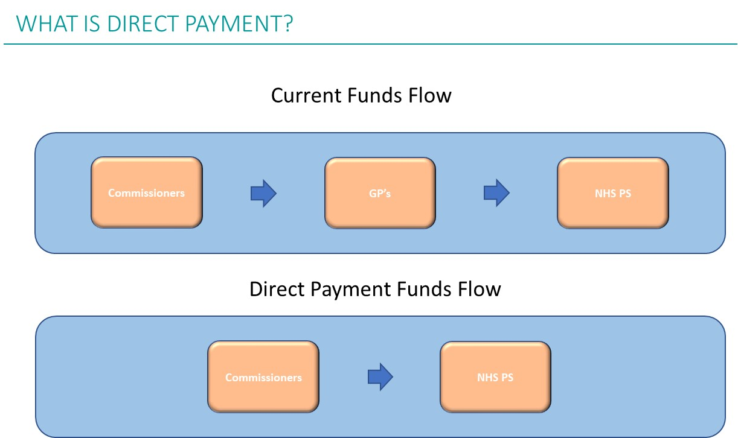

- Why can’t cash go straight to the property companies?
It can, but the Premises Cost Directions require that the GP agrees to this, which is done by the Section 52 letter.

- How do we cope with an NHS England staff member who is blocking Direct Payments because it is “not mandatory”?
Please get in touch with Adrian Snarr at NHS England who will be able to support. The initiative is being supported by Emily Lawson, National Director at NHSE&I.

